I have selected the audience from my final project work which is hospital managements perspective. So, For Hospital Management the main concentration is what vaccinations need to be reproduced to get that vaccines with less risk, reduce side effects and get cure for the patients to get that vaccine in time. Because the hospital management just need to know the demand of the medicine based on number of patients need to take the medicine for good health condition. To address the selected audience, my analysis of representing data in tree map. The use of this tree map is to display data in nested rectangles. Each rectangle has different size and color. So, I have considered few columns in the dataset to tell the story to the audience that are concentrated in the hospital managements point of view.

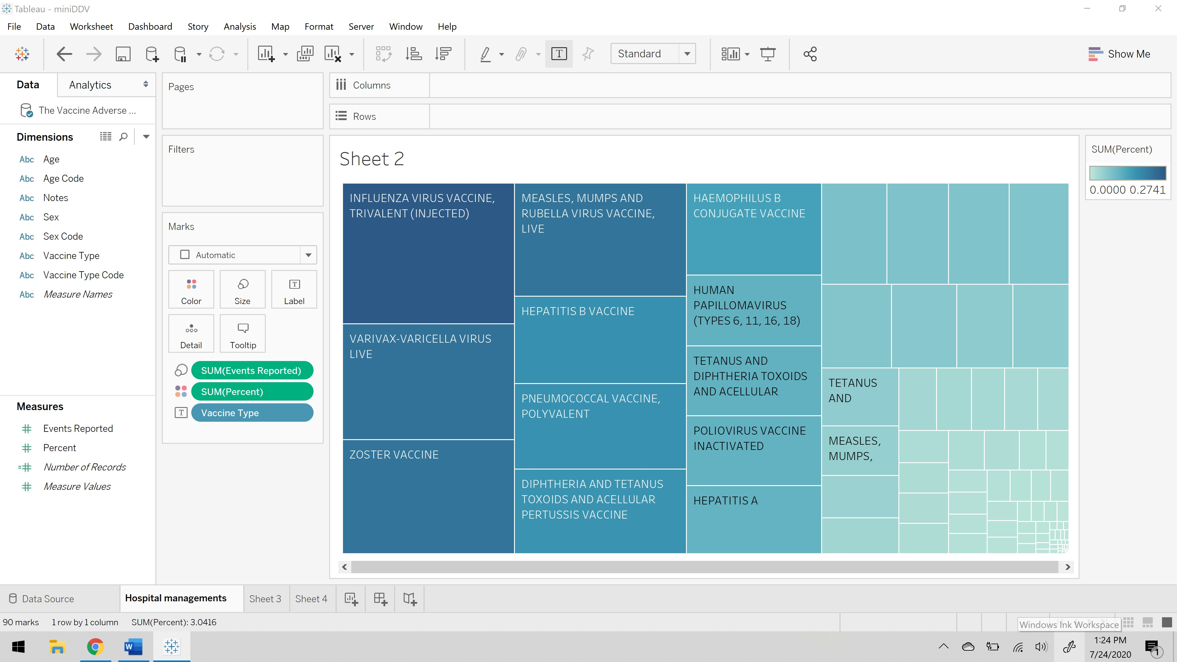

As you can see above visualization vaccines names as been placed on the label as you can see each rectangle is named as you hover on those rectangles. The size of each rectangle is defined by the events reported, which defines the complaints reported by the patients who has taken that vaccines. The color of each rectangle is defined by the percent, which is the risk exposure percentage. So, this visualization states a vaccine should be reconsidered to reduce the risk as per the hospital management’s perspective.

**Visual Hierarchy:** This refers to the arrangement or presentation off elements in a way that implies importance.

**Readability:** By adding redundancy improves readability. Which also means increasing the accuracy of the visualization.

**Annotations:** These are simply a text which indicates a point on a time series chart when a key event occurred. These key events help us understand the path of the data over time.

**Feedback Mechanism:** It is a loop system wherein the system responds to a perturbation. The responses may be in positive or negative. This feed back loop is the part of a system in which some portion or all the systems output is used as input for future operations. Each feedback loop has a minimum of four stages. During the first stage, input is created. Next in second stage, input is captured and stored. Later the third stage, input is analyzed and finally the fourth stage, the insight gained from analysis is used to make decisions

**References:**

1. <https://www.interaction-design.org/literature/topics/visual-hierarchy>
2. <https://www.displayr.com/improve-the-quality-of-data-visualizations-using-redundancy/>
3. <https://www.usaidassist.org/blog/improving-data-visualization-where-do-i-put-all-those-annotations#:~:text=Annotations%20are%20simply%20text%20that,%E2%80%94in%20time%2Dseries%20data.&text=Well%2C%20sometimes%20annotated%20time%2Dseries,chart%20has%20many%20of%20them.>
4. <https://searchitchannel.techtarget.com/definition/feedback-loop#:~:text=A%20feedback%20loop%20is%20the,a%20minimum%20of%20four%20stages.>